**GIT & GITHUB**

1. **Create a GitHub Account:**

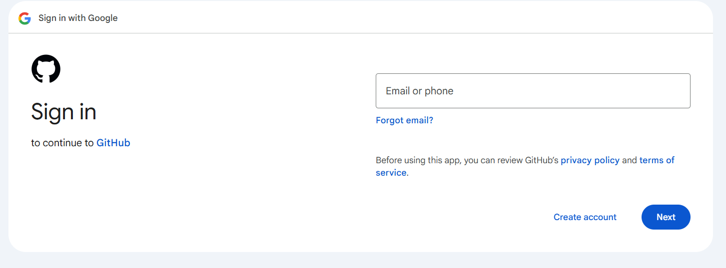

* Go to the web browser and search GitHub
* Click on the GitHub and click on signup
* Create the new account
* Enter the details required and click on create account

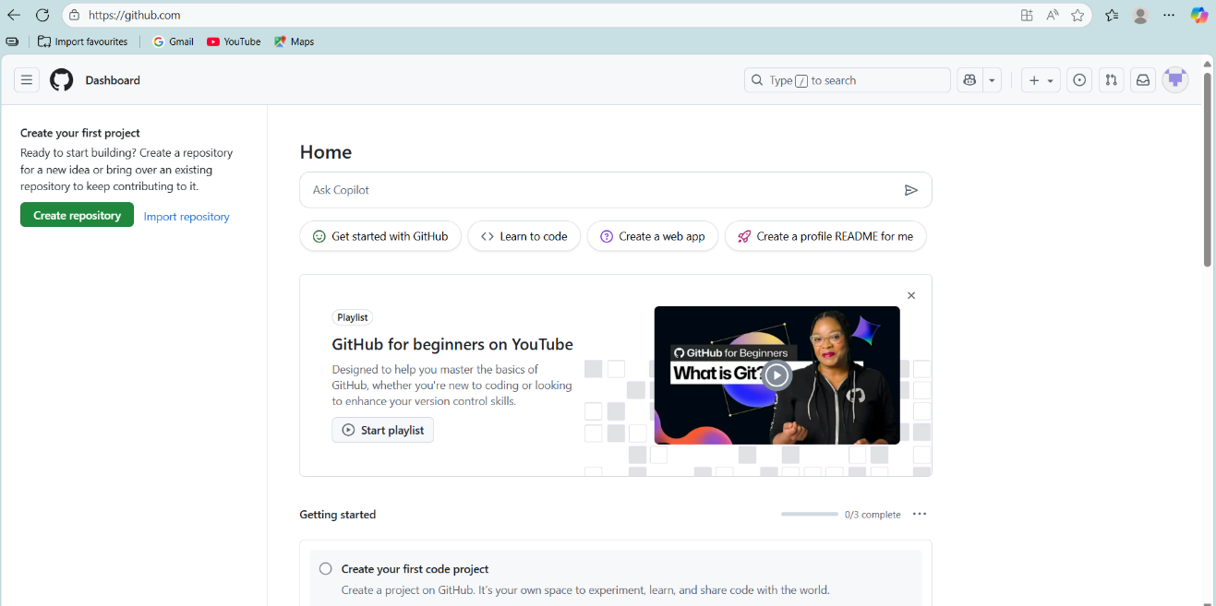

* You can see the acoount has created and redirected to the page.

1. **Set-up MFA For Git Hub Using Mobile App:**

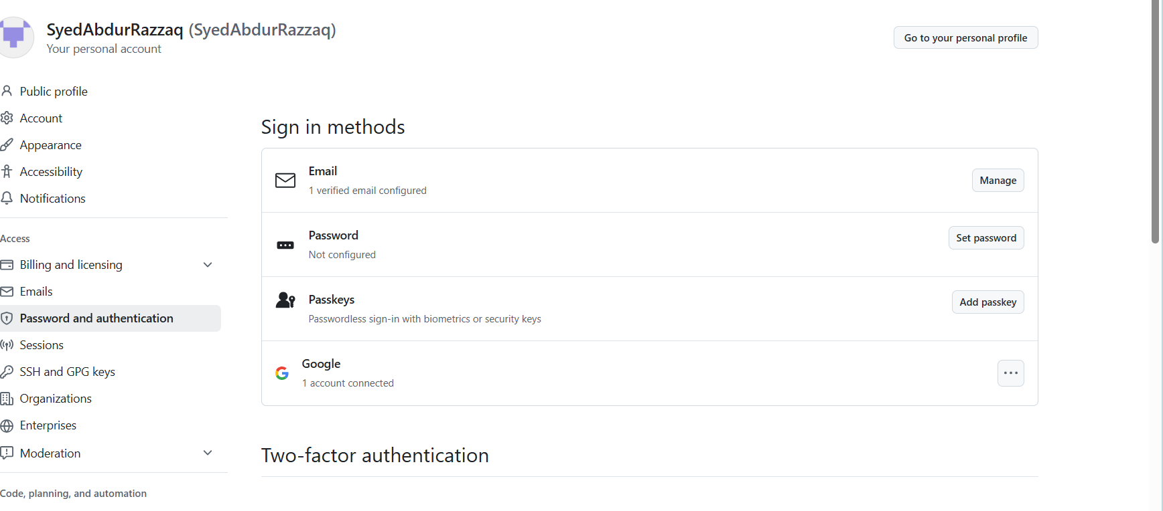

* for two factor authentication got to git hub settings



* Then go to password and authentication
* Click on enable two -factor authentication

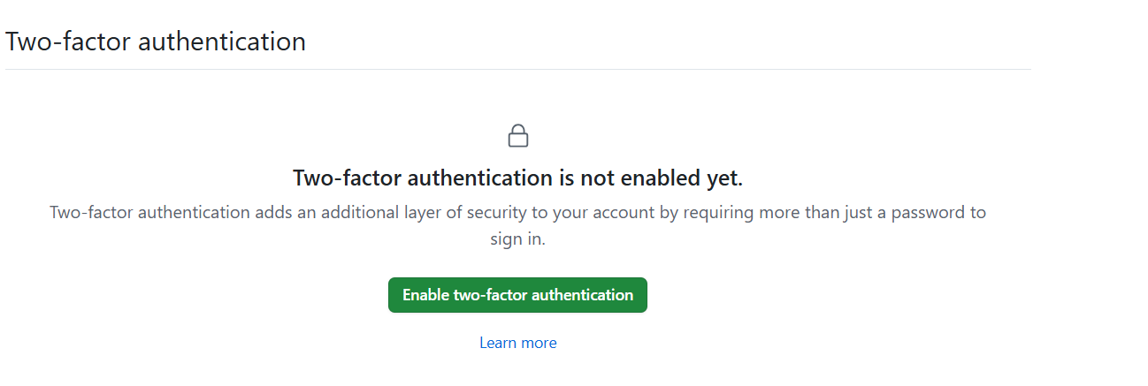

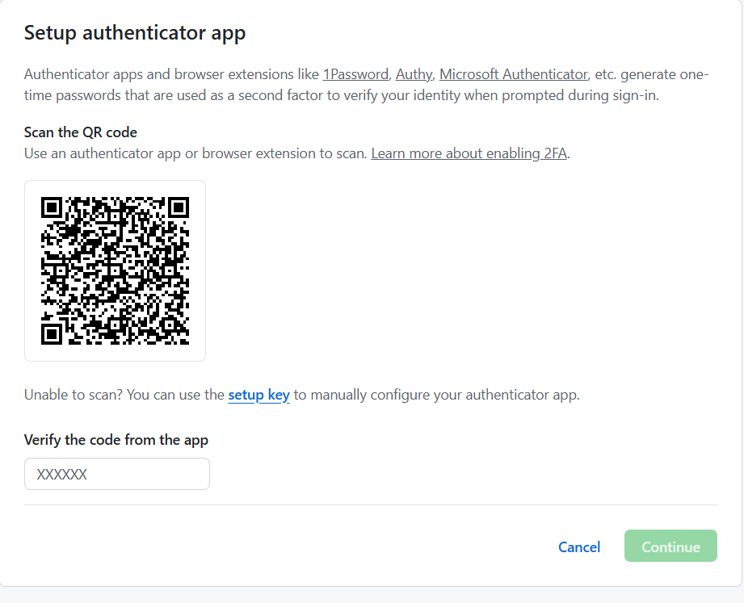

* Scan qr code from Microsoft authenticator app from mobile
* Enter the code shown
* Download the recovery codes file for recovery
* Save it then the 2 factor authentication mobile is done if you want uou can also add your phone number to verify.
* Authentication completed.

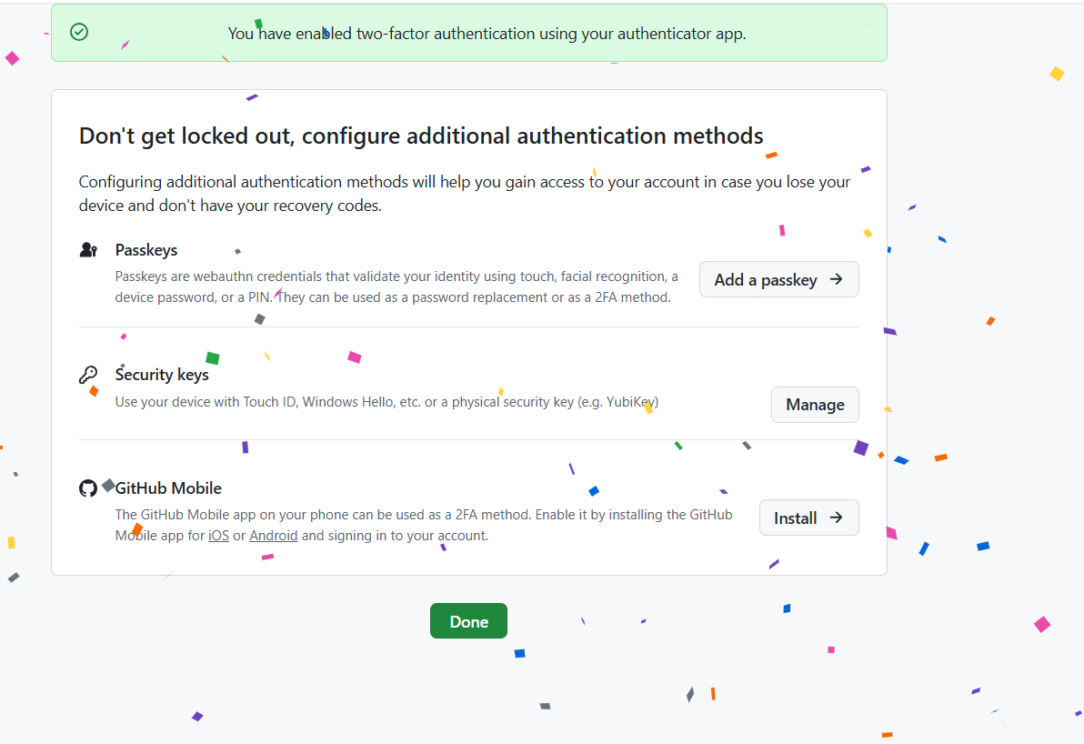

1. **Execute Commands Shown in the Video:**

**Git Setup & Configure:**

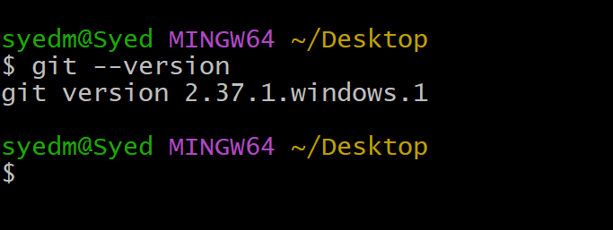

* Git --version: check the version of the git
* Create the directory: mkdir my-data
* Go to the directory: cd my-data

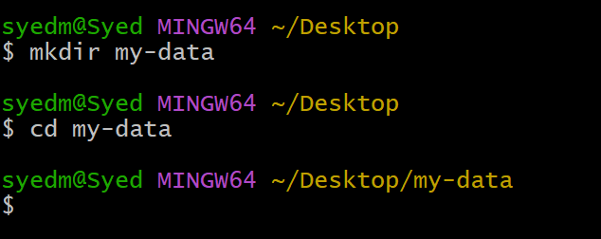

**Git init:**

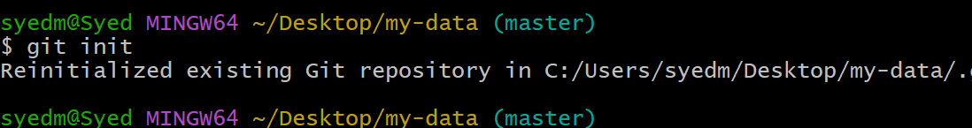

* Git init : It initializes a new Git repository in your current directory, allowing you to start tracking changes to files.

**Git config:**

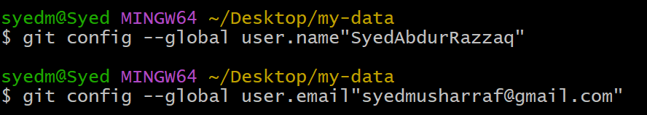

* Git config --global user.name “syed” : to add the user name
* Git config --global user.email “syedmusharraf.max@gmail.com” : to add the email

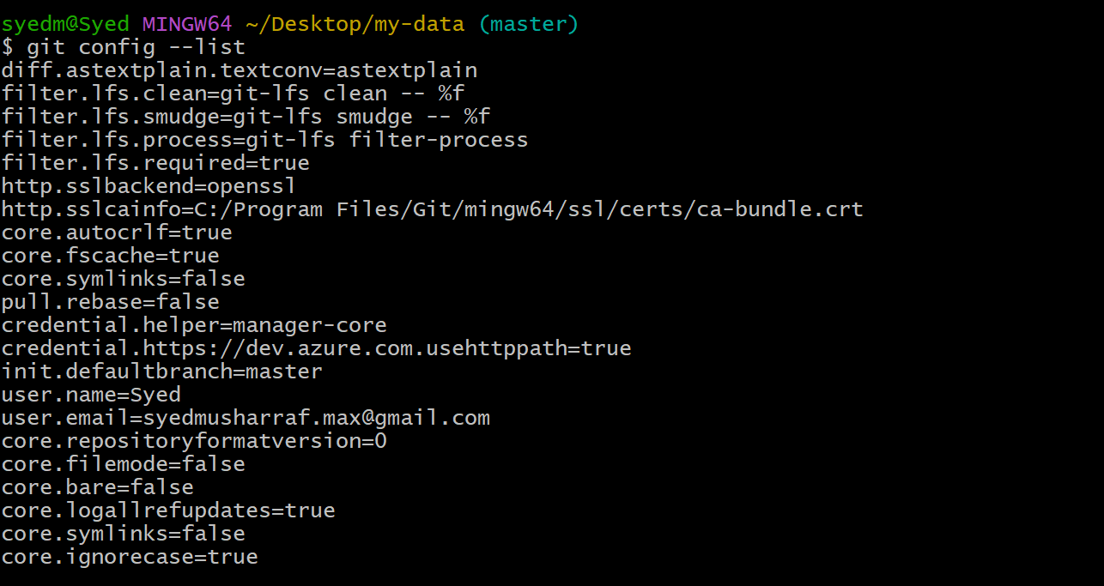

* Git config - -list to see the configuration of the git
* You can also see your user’s name and email you provided.

**Git Status:**

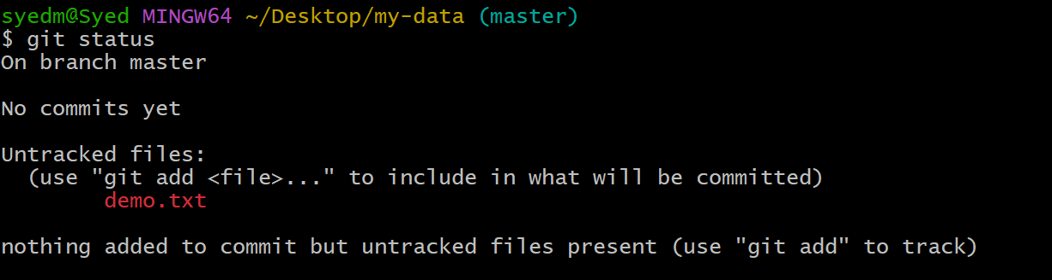

* Git status ; you see the working tree clean nothing to commit means there no other changes to be commited.

**Git Add:**

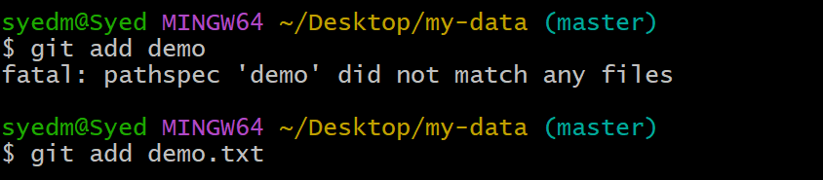

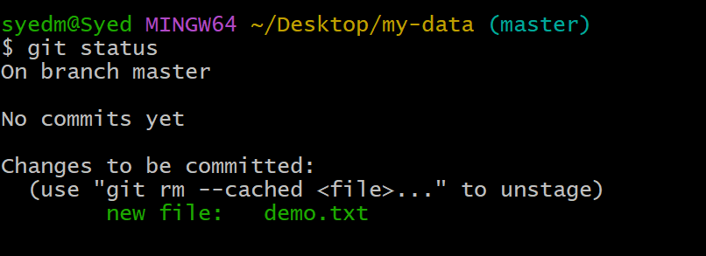

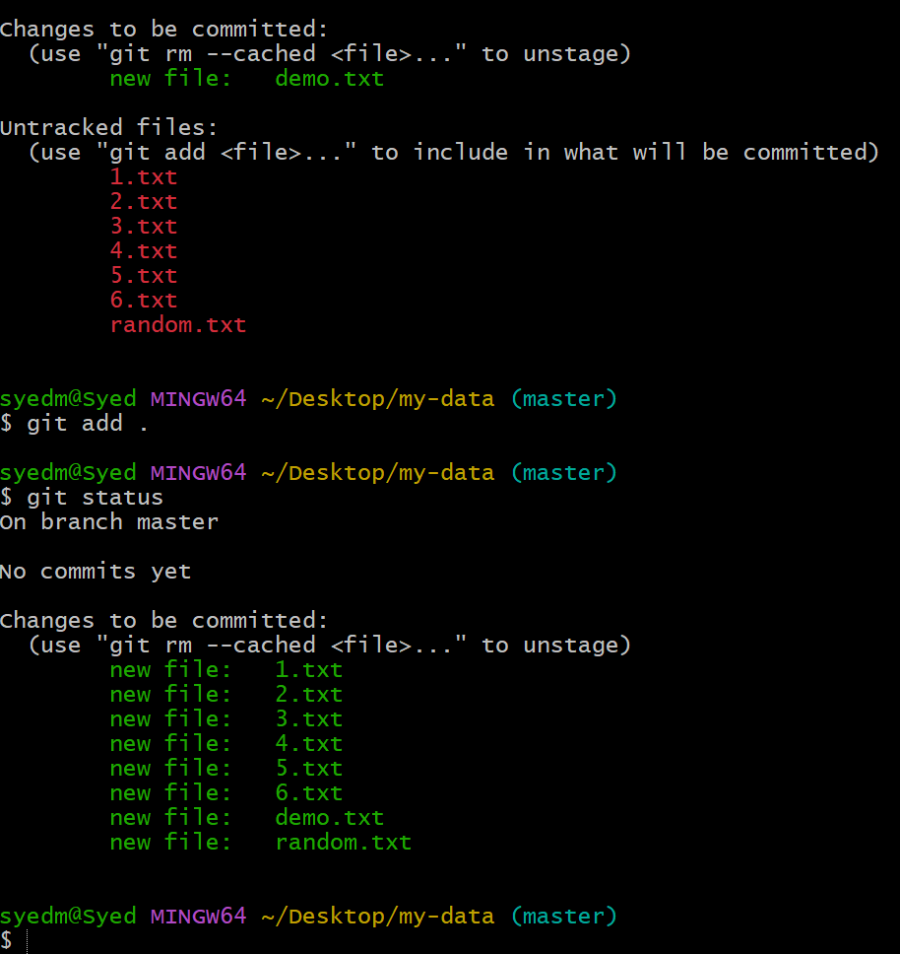

* Git add “file name” :to add the file
* Git status : you can see the new file has been added to the master origin

**Git Commit:**

* Git commit -m “messege” – store a copy in machine and provide messege what you have done.

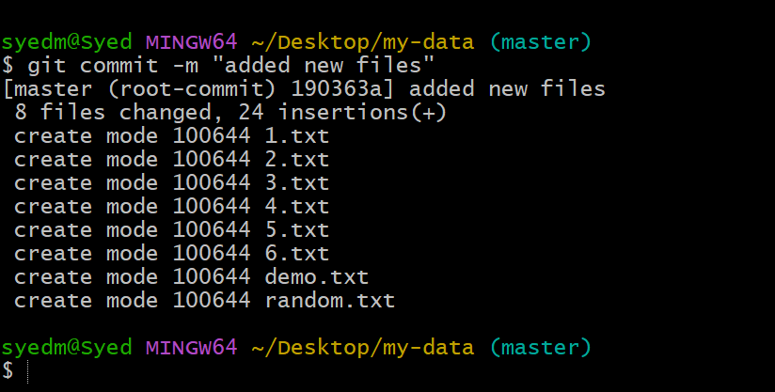

**Git log:**

* Git log : print all the logs you have made the changes with commit id and commit messege ,username , user email, date & time.
* For every commit there will be commit id generated
* Commit id you can revert the changes with it

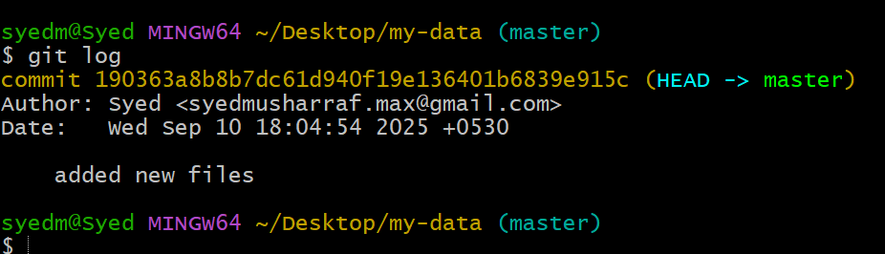

**ssh-keygen : key generation**

* Go to git hub create new repository to push all the files to repository.
* Git remote -v : it shows if any address has been configured we can see.
* Gir remote add origin “url” : to get remote access to the central repository.

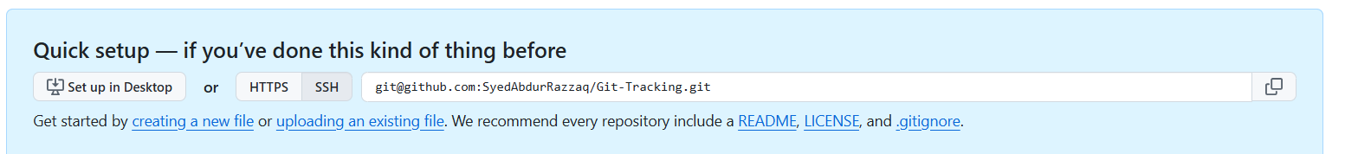



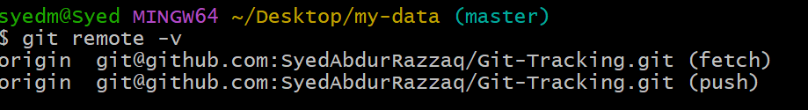

* We don’t have any address right now, so we will add it, for this we will generate a key using ssh-keygen

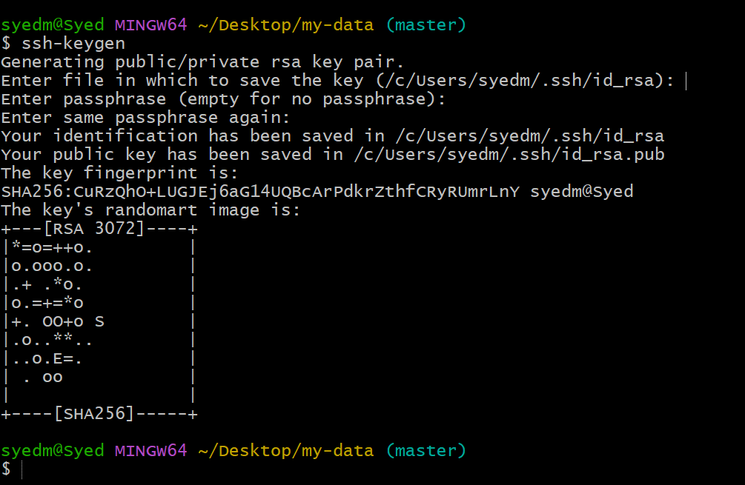

* copy the public key:

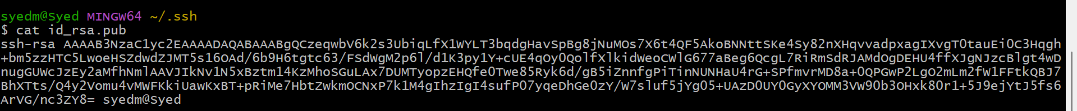

* paste the keygen it into github ->Settings->SSH and GPG keys

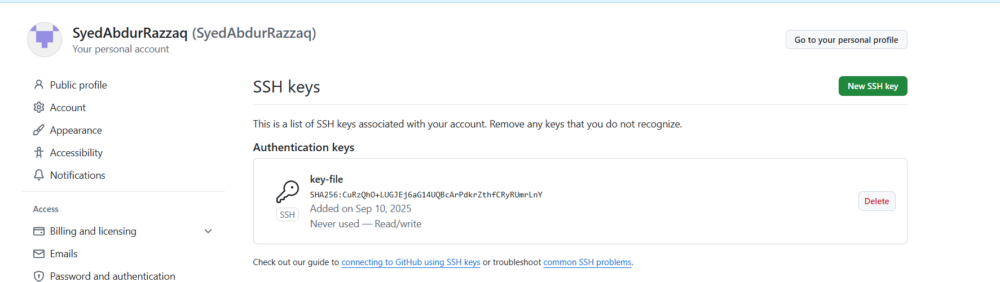

**Git Pull & Git Push**

* git push -u origin master : to push the code to master branch in the github repository.

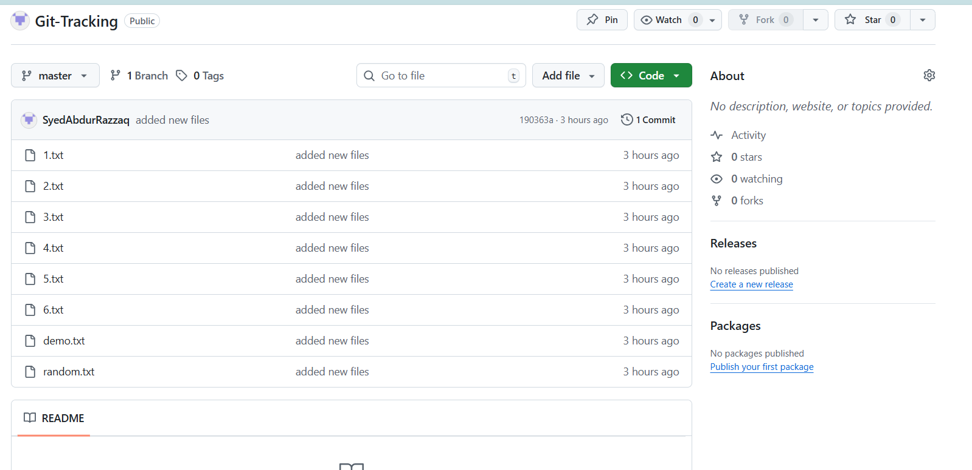

* Because we have not pushed to github repos, Check the status of git using git status

